

**Faculty of engineering - Shoubra**

**Benha University**

**Research Article / Research Project / Literature Review**

in fulfillment of the requirements of

|  |  |
| --- | --- |
| **Department** | **Engineering physics and mathematics** |
| **Division** |  |
| **Academic Year** | **Preparatory 2019-2020** |
| **Course name** | **Computer** |
| **Course code** | **ECE001** |

**Title: -**

**Artificial intelligence**

By:

|  |  |  |  |
| --- | --- | --- | --- |
|  | Name | Edu mail | B.N |
| 1 | محمد ايمن احمد عبدالمقصود علي | Muhammed195750@feng.bu.edu.eg |  |

**Approved by:**

|  |  |
| --- | --- |
| Examiners committee | Signature |
| Dr. Ahmed Bayoumi |  |
| Dr. Shady Elmashad |  |
| Dr. Abdelhamied Attaby |  |
|  |  |
|  |  |

* Application brief

The future of humanity depends on artificial intelligence. Artificial intelligence is so important as it will change totally the future of humanity. Artificial intelligence will help students to get a better education. Artificial intelligence will help us to improve medicine as it will help doctors for better and more detailed diagnosis and will help us to make better medicines . And it will help us in economy as it will do financial tasks with high efficiency.

I choose to talk about this topic due to its vital role in the future as we will use robots to do difficult tasks . Artificial intelligence in programming helps us to predict what will happen in the future. For example china used artificial intelligence to predict corona cases and this helped china to struggle this pandemic virus. But if we used artificial intelligence in a bad way this will be very dangerous as robots can kill people easily. So I will try to talk about artificial intelligence good and bad sides.

**Screenshots section: 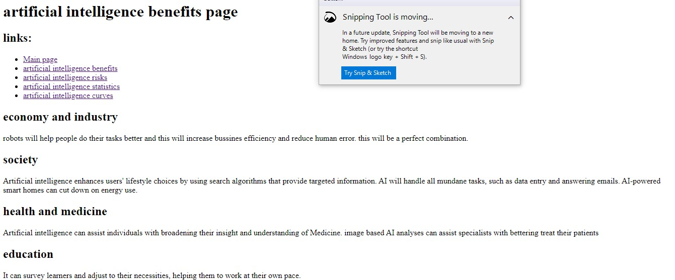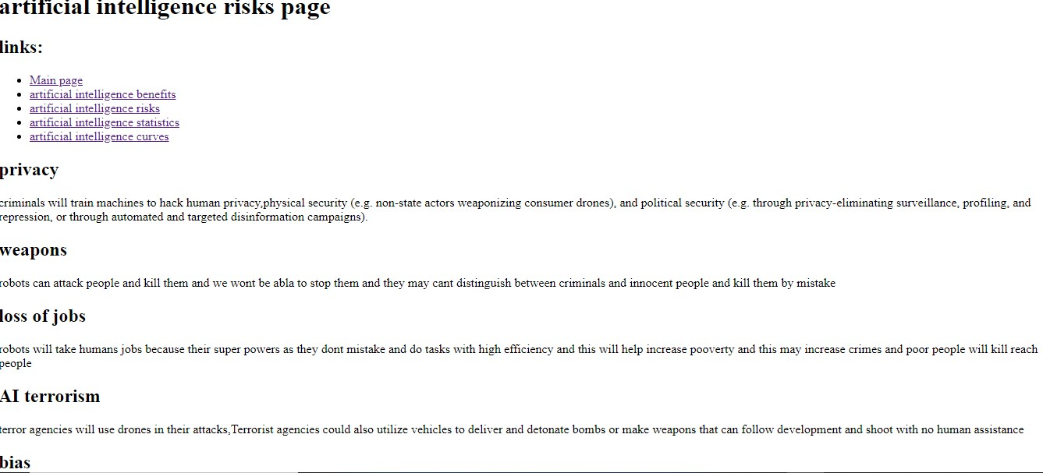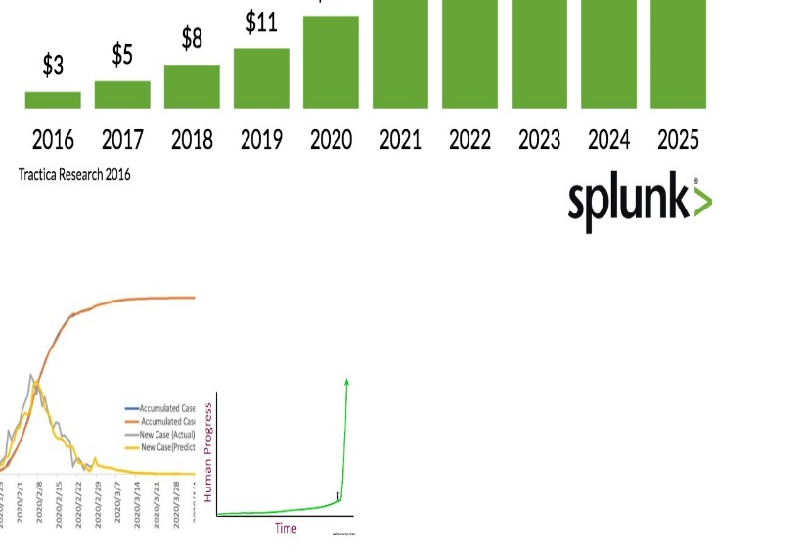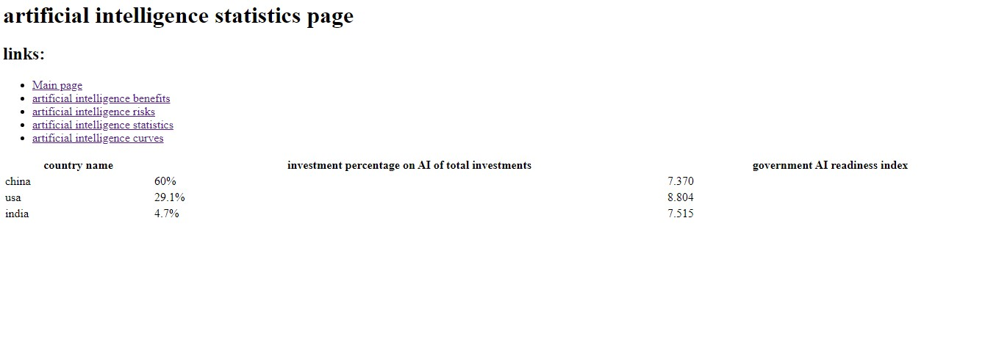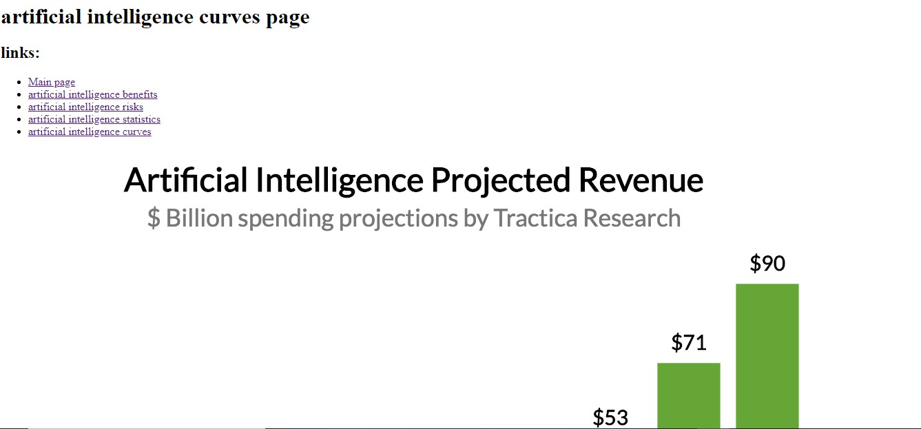**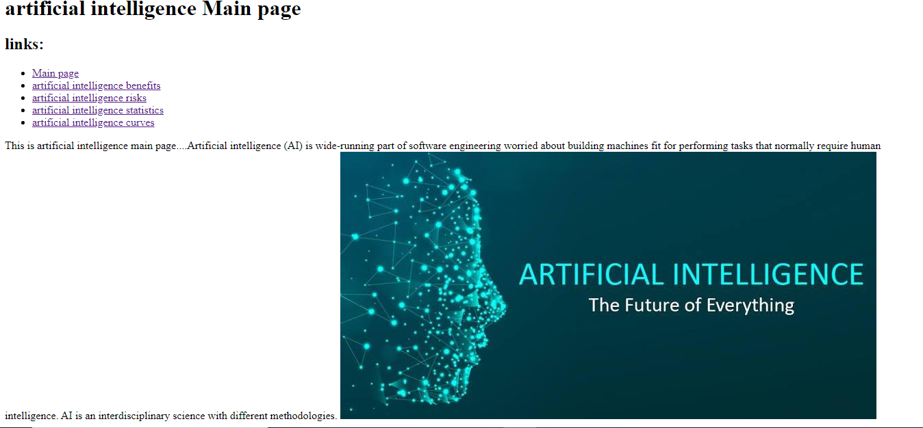

**Source code section:**